MSBX 5420 Team Project

April 25, 2020

Team Torrey’s Peak

**Design Document**

*Descriptive Stats*

Team Torrey’s Peak used the COVID-19 dataset comprising more than 3500 CBC news articles for our MSBX 5420 team project. This dataset retrieved from kaggle contains the authors, the title, the publish date, the description about the story, the main story and the url. For the start of this project, we wanted a closer look into the descriptive statistics within the dataset. With a goal in mind to focus on the sum of articles over time, we first created a line of code to put the publish dates into the correct date form. Next, we created an index naming this news_2020 to adjust the publish date to January 1, 2020 and created a new column to count how many articles were in each day. Figure A shows the results of the new article count.

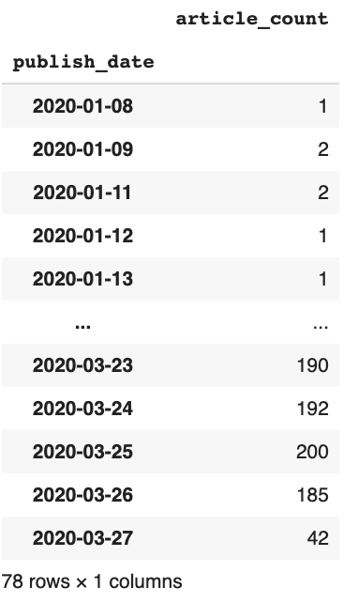

**Figure A**

With this new column, we imported matplotlib and pivoted the index. Using the plt.subplot function, we set the figsize to 10 and 6. Also giving the suptitle “Articles over Time (Day).”

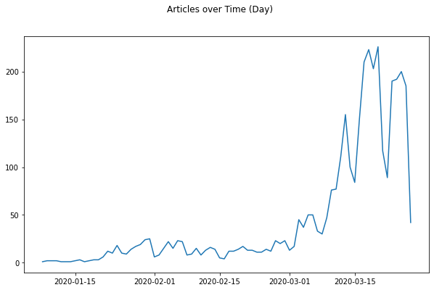

**Figure B**

The next step into our descriptive statistics looked into the sum of the number of articles per week. Using the news_2020 index, we grabbed the publish_date and created a weekly_count index using resample(‘W’).sum(). Then, we plotted the articles over time once again using the subplots and figsize to 10 and 6. Also giving the suptitle the name “Articles over Time (Week).” Finally plotting the weekly count and article count shown below in Figure C.

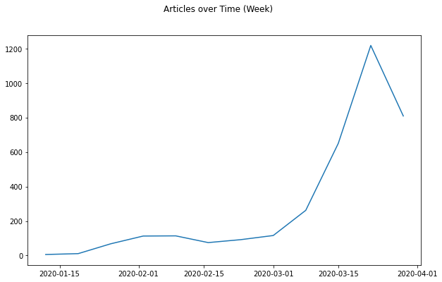

**Figure C**

*Word Cloud*

Created word clouds for all text in the articles and also created word clouds for December, January, February and March to see if the articles had changed over time. Used Python to read the csv data and used the publish_date as the index. Found 15.8M words in the text of the articles and created a total word cloud.

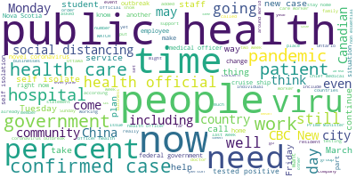

**Figure D**

After running a word cloud for all articles, we split up the articles by month.

Here is December.

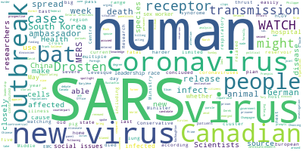

**Figure E**

And March.

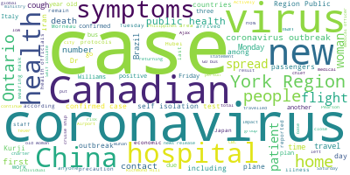

**Figure D**

*Spark Repetitive Words*

*insert here

*Topic Modeling*

For the bulk of this project, we decided that it would be interesting to create a topic model that analyzed the text of all of these articles and would create 12 topics based off of words within these articles. By first creating a jupyter notebook, we install tmtoolkit. From there, a corpus of all text from the articles needed to be created, and this was done by using csv.reader and with a for loop that appended text from each article. The length of this corpus was 3567, which matches the amount of articles that were examined. We then imported nltk in order to remove stopwords from the corpus since these words do not give any insight into the topics of the articles. TMPreproc was also downloaded to tokenize, remove special characters, add stopwords that we deemed should be avoided like ‘http’ or ‘nt.’ In addition, we also converted the corpus to lowercase.

*Small - Topic Model*

In order to look more specifically into these topic models, we divided them into a smaller (more specific) and bigger (less specific) half. By doing this, we were able to see which topic model would perform better. With the smaller topic model, we removed uncommon tokens with a threshold of 0.01 and removed common tokens with a threshold of 0.9. This was to ensure that any word that was rarely used or overused would not be included in the topic model. A Numpy array was created with the words and from there an LDA model was run with a number of topics of 12, beta of 0.5, and number of iterations of 1000. We played with these parameters, and these appeared to give us the best ‘smaller’ topic model. Below in Figure _ , we provide a preview of the topics and includes some topics from Canada given that our articles were from a Canadian news company. Figure _ demonstrates several interesting topics that could give insight into the Coronavirus outbreak such as *cruise* and *passengers* as well as *health* and *masks*.

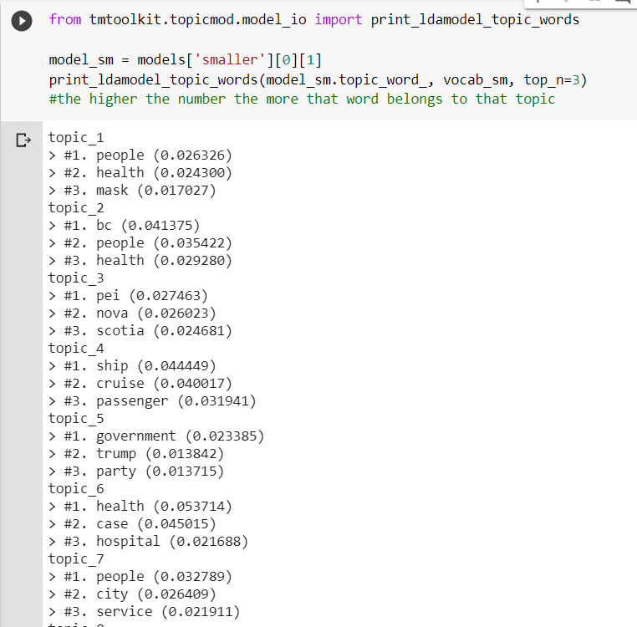

**Figure _**

*Big - Topic Model*

*insert here